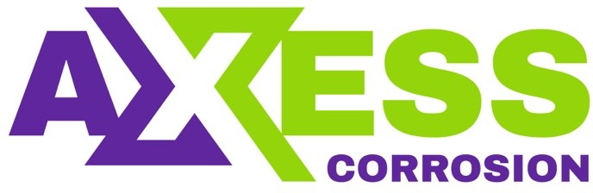
Daily Progress Report

Installation / Location | Halul Island
Subject | Corrosion Monitoring Activities
Contract Number | LC241047A0
Assigned Axess Representatives | Stuart Dunthorne
Date of Issue | 21-07-2025

Activities Summary
Today the coupon location spreadsheet was completed with all of the new/installed coupon information for PS-3. Also made a start on draft final report for PS-3. The retrieved coupons from Halul and PS-3 are now packaged up in a box and we are just awaiting the air freight template form to complete.
The retrieval equipment arrived back at the OAT workshop mid-morning, so servicing commenced soon after. 3 retrieval tools were serviced and ready for pressure testing.
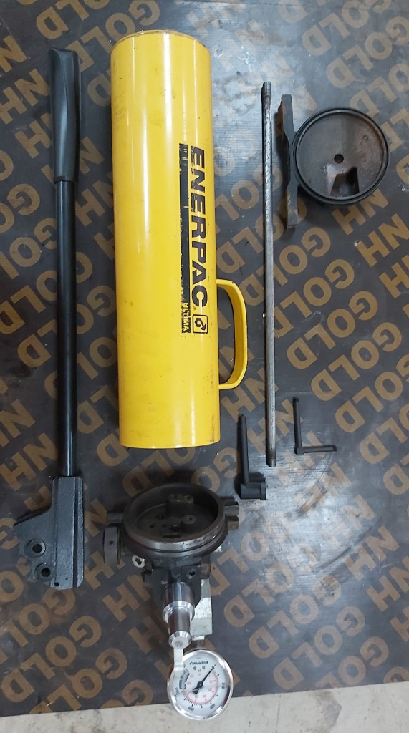
The faulty Enerpac pump was stripped down and inspected as far as possible. Although somewhat dirty inside, we couldn’t identify anything which was obviously broken. The pump was rebuilt but unfortunately the problem persists. It’s likely that the pump needs a new seal kit.

Time | Activities
06:00 to 11:00 | Complete updating CC Location spreadsheet for PS-3. Commence strip down of equipment
11:00 to 12:00 | Lunch
12:00 to 18:00 | Continue servicing of retrieval tools and perform strip down & inspection of Enerpac pump

Observations & Recommendations
There is an old Enerpac pump here in the workshop that is still just about functional but does leak hydraulic oil and generally is in quite poor condition. We will use this pump to perform pressure tests of the equipment that we are currently servicing. We would not recommend relying on this pump for offshore, as it will probably stop working at any time, so we really do need to get the other pump fixed prior to the next campaign.

24 Hour Lookahead
The plan for Tuesday 22nd July is to perform the strip down of 2 service valves in the morning then commence with pressure tests of everything in the afternoon.

Stuart Dunthorne – Axess-Corrosion. – sdunthorne@axess.energy

